# Introduction

SolidWorks has been used as a CAD software, it contains solid modelling, Motion studies, Simulation PhotoView 360, e-drawing and many other features.is used to have a complete CAD model for KR6 r900 sixx KUKA arm.

In Simulation and Analysis, you can test your designed product in real environment. In simulation process the model can be tested against parameters like static and dynamic response, fluid dynamic, heat transfer. It also supports thermal, fatigue, structural and motion analysis.

In our project SolidWorks is used to have a CAD model for KR6 r900 sixx and to perform a motion analysis study on the model, designing a base to fix arm on it and apply a stress analysis on it and creating an animation video of model motion.

# Complete CAD model

## Searching for suitable model

All CAD models for KR6 r900 sixx in KUKA website or GrabCAD were step imported parts which is treated as a one body so joints can’t rotate therefore, motion study can’t be performed as it was impossible to apply motors at the robot joints. The solution for this issue was done by converting step parts into assembly, that is done through several steps:

1. Open the stp file part while in SOLIDWORKS. Select the file type to be .stp
2. Click the OPTIONS tab, select Import multiple bodies as parts and click OK
3. Then click Open

SolidWorks will create an assembly and create an individual part file for each multibody (Part1, Part2, Part3 etc.…)

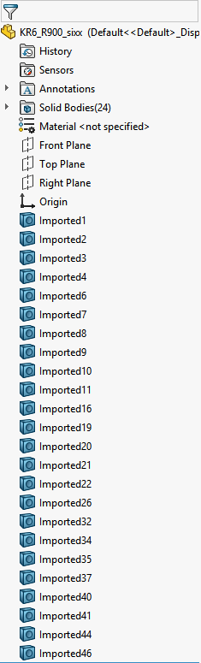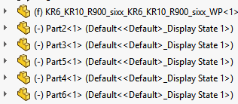

Conversion

Figure .1 ‑2 assembly parts

Figure .1 ‑1 step parts

## Modifications on CAD model

### Material and weights

The material wasn’t specified and the model was solid from entire therefore, the total mass for the robot was 33.74 Kg which must be approximate to 52Kg (according to KR6 R900 sixx dimension manual). Which is achieved by making the model hollow with the use of shell feature and adding to joins point masses similar to the real motors with mass approximate equal to motors masses.

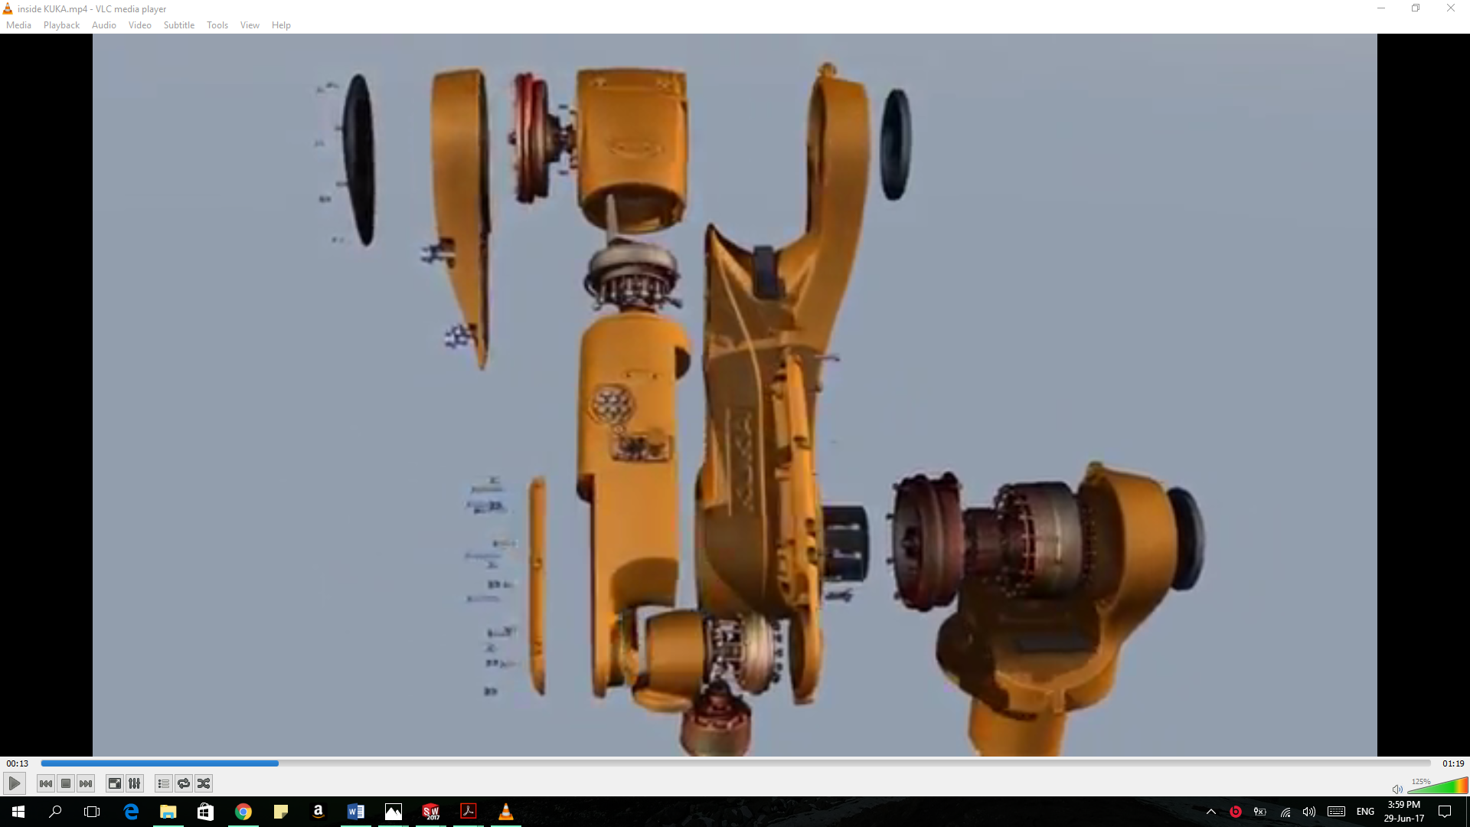

Figure ‑ KUKA robot motors

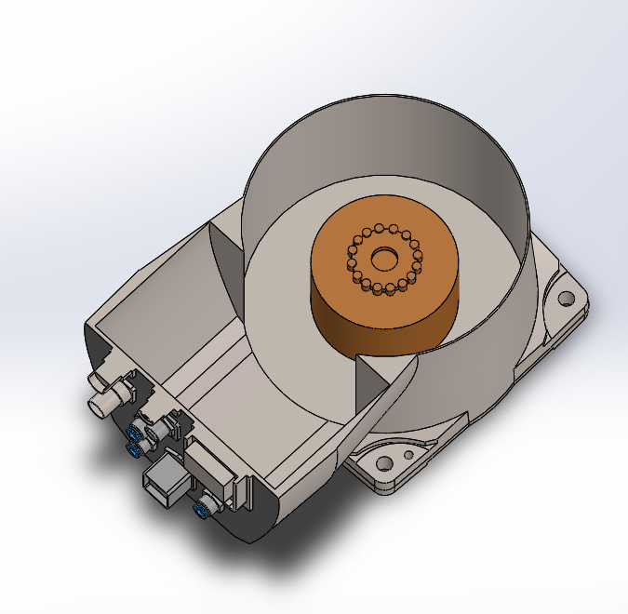

Figure ‑ Motor 1

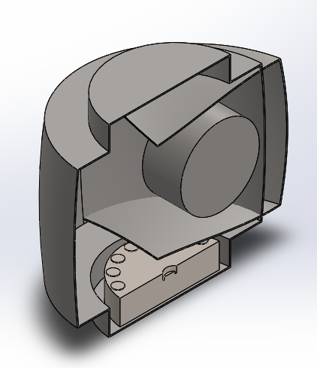

Figure ‑ Motor 3

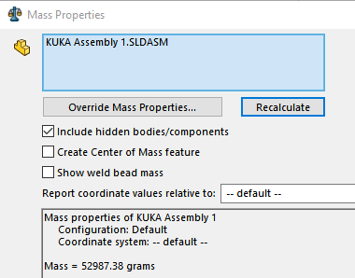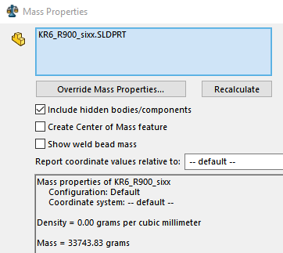

Figure ‑final mass

Figure ‑ Before adjusting mass

### Spindle

To have a complete model for our graduation project a router spindle and its holder were drawn as a model for the used one.

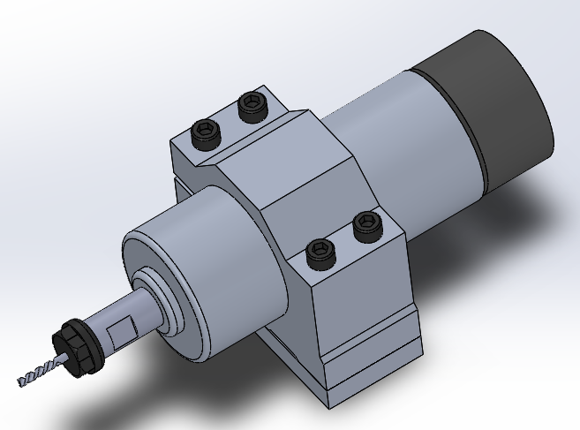

Figure ‑ Spindle model

### 

Figure ‑ Final CAD model

# Motion studies

Motion studies are graphical simulations of motion for assembly models. They simulate and animate the prescribed motion for a model. SolidWorks offer three different types of motion study, Animation, Basic Motion, Motion Analysis. Also offer mate controller that show, save the positions of assembly components at various mate values and degrees of freedom and create simple animations between those positions.

Animation can be used to animate the motion of assembly. If you simply wish to create some nice visuals for presentation or marketing without consideration of mass and gravity effects, then animation is for you.

Basic Motion is an extra layer of complexity that takes into consideration the effects of mass, motors, springs, contact, and gravity on assemblies.

Motion Analysis is the top tier of motion study provides accurately simulation and analyze the motion of an assembly while incorporating the effects of Motion Study elements (including forces, springs, dampers, and friction). Motion Analysis can also be used to plot simulation results for further analysis.

Therefore, Motion Analysis is used to simulate the model, generating results and plots of the simulation and Animation is used to make a video for motion.

## Animation study

Animation study is done to make an animation video of the moving parts with the use of limit mates. Limit angle mate is an advanced mate type that is performed by selecting two planes which rotate with respect to each other giving the desired range to mate and input a maximum and minimum value for the angle to specify the desired range of motion (specification manual page 16). Another advantage of limit angle is that it prevet collasion of moving parts to occure.

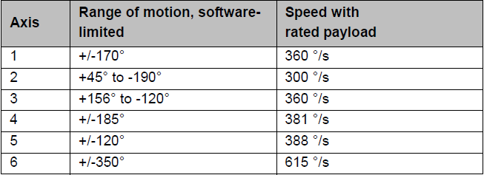

Figure ‑ Axes range of motion

## Motion analysis

On implementing motion analysis by adding a motor at the required location to start simulating robot a problem was arise, the model explode on running the simulation where some of the parts flew off the screen, this was due to redundancy constrains. For Motion Analysis studies, having redundant mates is the equivalent of over-defining the model.

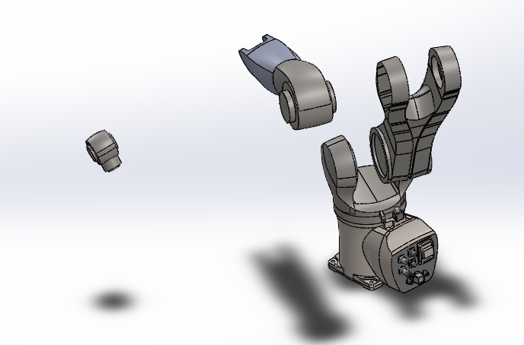

Figure ‑ Redundancy constrains problem

This issue was solved by using mechanical mates of hinge type instead of standard mates. Hinge mate limits the movement between two components to one rotational degree of freedom. It has the same effect as adding a concentric mate plus a coincident mate and also limit the angular movement between the two components by adding limit angles. Reducing the negative effect of redundant mates on analysis.

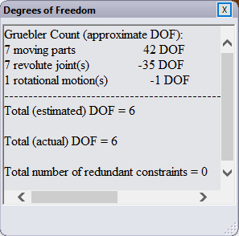

Figure ‑ Zero redundant constraints

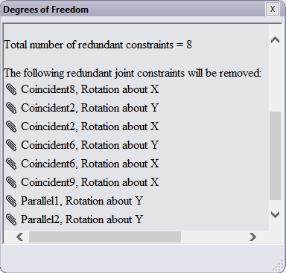

Solving redundant constrain problem

Figure ‑ Redundant constraints

Now motors can be added to the model to perform any motion and results as motor torque, velocity, acceleration and force are generated.

## Results of motion analysis study

By assigning a motor to simulate the motion of axis and plotting the results to achieve this motion we found:

* Results of motor torque for axis 1 to move 100 degrees in 4 seconds:

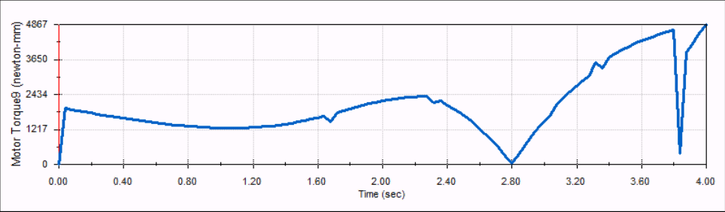

Figure ‑ Motor 1 torque

Knowing that the actual motor torque for axis 1 is 4.5 N.m so the motion analysis result is approximate to actual torque.

Motor torque vary with time because of the motion of the links beyond the motor which has an effect on the torque by changing the loads carried by the motor.

* Motor 2 torque to move 60 degrees in 2 seconds:

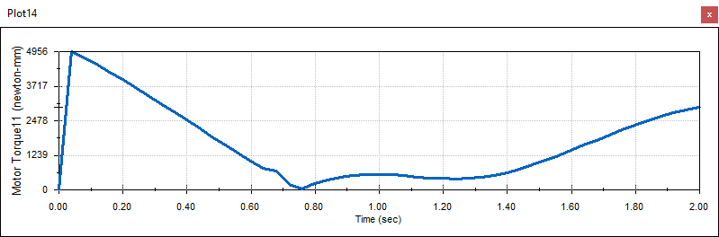

Figure ‑ Motor 2 torque

Where the actual motor torque is 4 N.m

* Motor torque for axis 3 to move 75 degrees in 1.8 seconds:

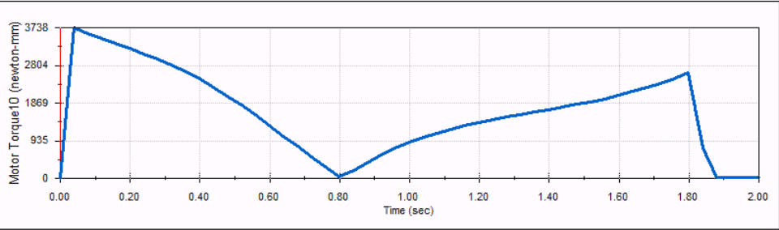

Figure ‑ Motor 3 torque

Knowing that the actual motor torque for axis 3 is 3.5 N.m so the motion analysis result is approximate to actual torque.

Motion analysis results and plots has a trace path option that can trace the path of a point in the assembly. The selected point is end mill vertex to create the curve feature that represent the motion of the links. By assigning a data point motors to the joints whose data is imported from excel spreadsheet of file type .csv containing two columns, first represent time in seconds while other is degrees of rotation. The generated curve of adding this data to joints 1-5 is an arc shape.

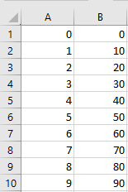

Figure ‑ Data point

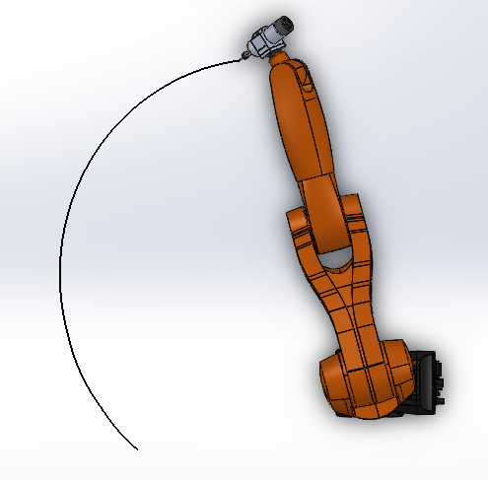

Figure ‑ Trace path curve

# SolidWorks simulation

SolidWorks simulation is used to make a stress and strain analysis on designed base model to have a verification on the calculated dimensions of the base before starting fabricating it.

Static study is used to perform this analysis as we use maximum loads acting on foundation base according to specification manual (page 29&30)

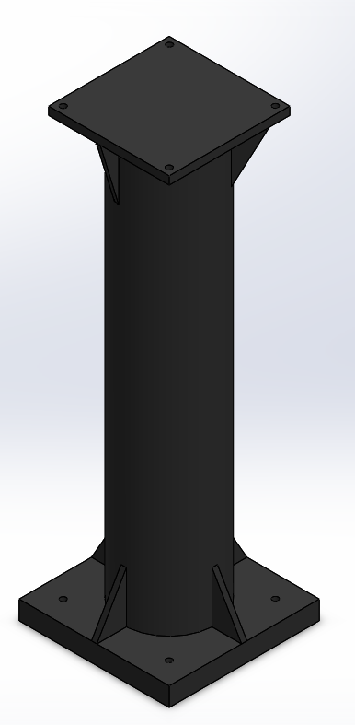

Figure ‑ Base model

## Result of static analysis

### Material properties

|  |  |  |
| --- | --- | --- |
| ****Model Reference**** | ****Properties**** | ****Components**** |
|  | |  |  | | --- | --- | | ****Name:**** | **Galvanized Steel** | | ****Model type:**** | **Linear Elastic Isotropic** | | ****Default failure criterion:**** | **Max von Mises Stress** | | ****Yield strength:**** | **2.03943e+008 N/m^2** | | ****Tensile strength:**** | **3.56901e+008 N/m^2** | | ****Elastic modulus:**** | **2e+011 N/m^2** | | ****Poisson's ratio:**** | **0.29** | | ****Mass density:**** | **7870 kg/m^3** | | **SolidBody 1(Cut-Extrude3)(Base)** |
| **Curve Data:N/A** | | |

### Loads and fixtures

| Fixture name | Fixture Image | Fixture Details |
| --- | --- | --- |
| Fixed-1 |  | |  |  | | --- | --- | | Entities: | 1 face(s) | | Type: | Fixed Geometry | |
| Resultant Forces   |  |  |  |  |  | | --- | --- | --- | --- | --- | | **Components** | **X** | **Y** | **Z** | **Resultant** | | **Reaction Force(N)** | 1361.24 | 1297 | -9.45893 | 1880.23 | | **Reaction Moment (N.m)** | 0 | 0 | 0 | 0 | | | |

| ****Load name**** | ****Load Image**** | ****Load Details**** |
| --- | --- | --- |
| **Vertical** |  | |  |  | | --- | --- | | Entities: | **1 face(s)** | | Type: | **Apply normal force** | | Value: | **1297 N** | |
| **Torque** |  | |  |  | | --- | --- | | Entities: | **1 face(s)** | | Type: | **Apply torque** | | Value: | **880 N.m** | |
| **Horizontal** |  | |  |  | | --- | --- | | Entities: | **1 face(s)** | | Type: | **Apply normal force** | | Value: | **1362 N** | |

### Mesh information

|  |  |
| --- | --- |
| Mesh type | Solid Mesh |
| Mesher Used: | Standard mesh |
| Automatic Transition: | Off |
| Include Mesh Auto Loops: | Off |
| Jacobian points | 4 Points |
| Element Size | 42.7962 mm |
| Tolerance | 2.13981 mm |
| Mesh Quality Plot | High |

|  |  |
| --- | --- |
| Total Nodes | 8014 |
| Total Elements | 4135 |
| Maximum Aspect Ratio | 46.551 |
| % of elements with Aspect Ratio < 3 | 38.5 |
| % of elements with Aspect Ratio > 10 | 15 |
| % of distorted elements(Jacobian) | 0 |
| Time to complete mesh(hh;mm;ss): | 00:00:01 |
| Computer name: | DONNAMUSTAFA |
|  | |

### Study results

| Name | Type | Min | Max |
| --- | --- | --- | --- |
| Stress | VON: von Mises Stress | 1.209e+003N/m^2  Node: 5564 | 1.228e+007N/m^2  Node: 546 |
| **Base-Analysis-Stress-Stress1** | | | |

| Name | Type | Min | Max |
| --- | --- | --- | --- |
| Displacement | URES: Resultant Displacement | 0.000e+000mm  Node: 347 | 1.378e-001mm  Node: 730 |
| **Base-Analysis-Displacement-Displacement1** | | | |

| Name | Type | Min | Max |
| --- | --- | --- | --- |
| Strain | ESTRN: Equivalent Strain | 5.733e-009  Element: 3189 | 4.620e-005  Element: 3828 |
| **Base-Analysis-Strain-Strain1** | | | |

### Conclusion

For the previous analysis it is obvious that the calculated dimensions are safe to be fabricated.

# References

* <http://www.engineersrule.com/motion-studies-and-how-to-do-them/>
* SolidWorks help
* http://help.solidworks.com/2017/English/SolidWorks/cworks/c_Study_Types.htm
* SolidWorks forums
* Dimensions manual
* Specification manual
* https://robotics.stackexchange.com/questions/10256/dynamic-torque-simulation-for-a-6-dof-robotic-arm